Task #1  
  
Prompt:  


Code:  
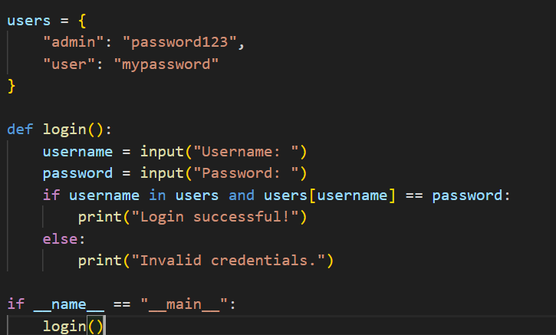  
  
Secure Version Prompt:  
  
  
  
  
Code:  
  
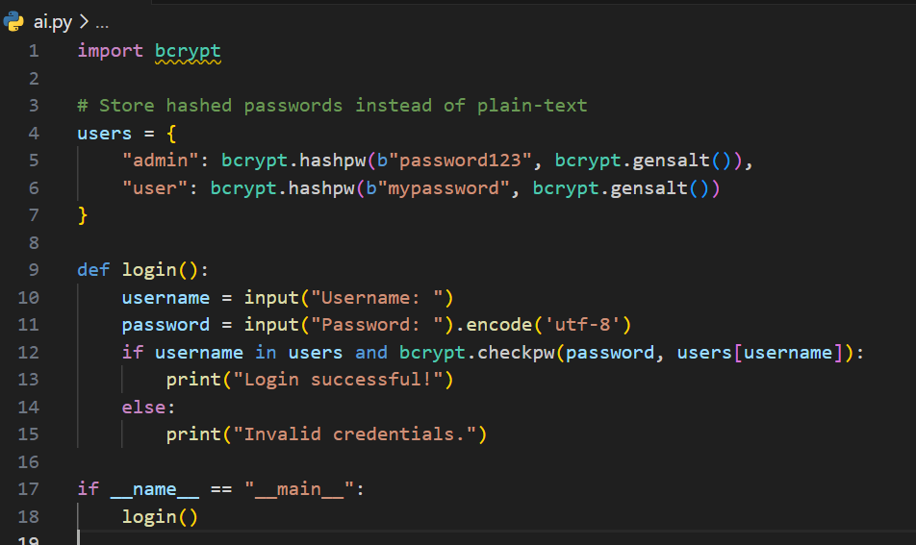  
  
Task # 2  
  
Prompt:  
  
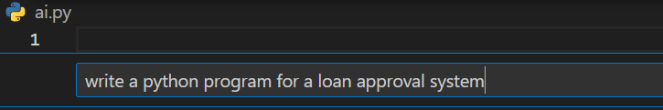  
  
Code:  
  
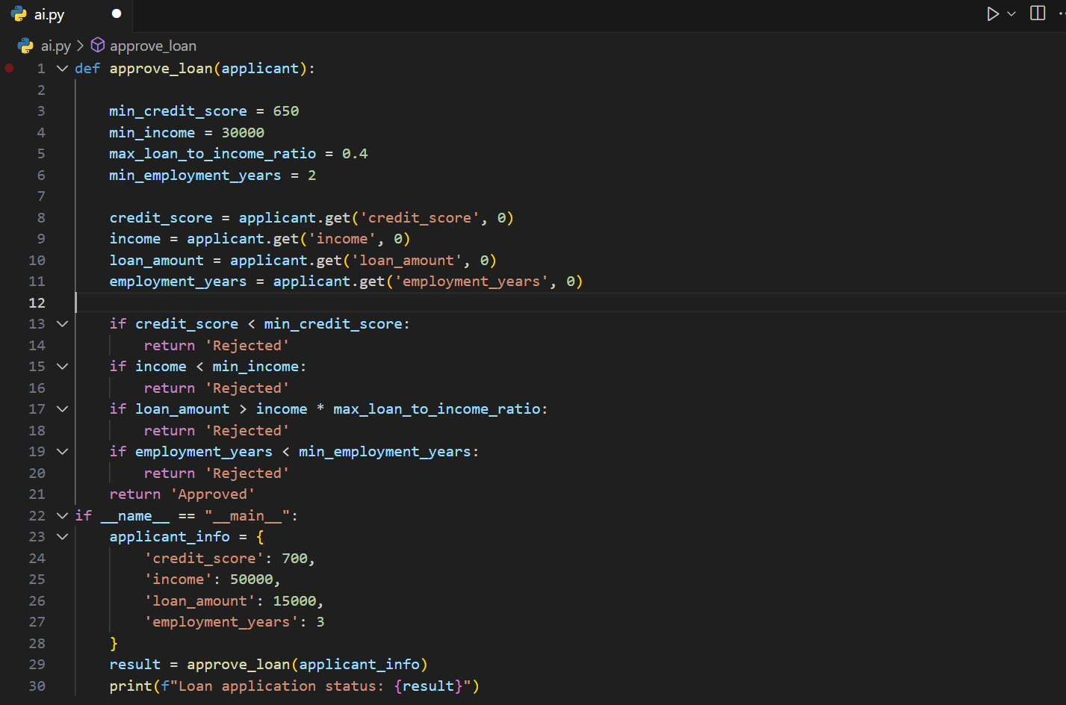  
  
The code provided gives us an unbiased code as a result of mitigation is not required but minor improvements can be done in order to improve user experience.  
  
  
  
  
  
  
  
  
  
  
  
  
  
  
  
  
Task #3  
  
Prompt:  
   
  
  
  
 Code:  
  
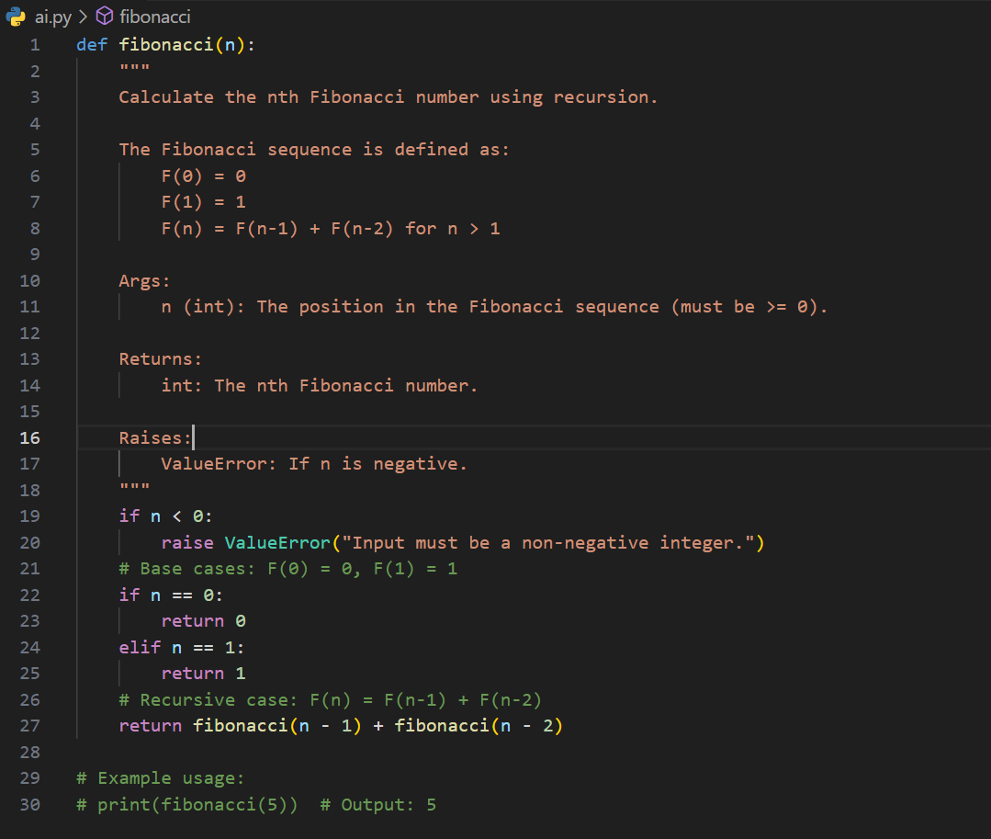  
  
  
  
  
  
Task #4  
  
  
Prompt: